1. Produce a line plot showing multiple lines with proper labels and legend. Describe what conclusions you can draw from this plot.

**Data set:** <https://www.kaggle.com/code/alexisbcook/line-charts/data?select=spotify.csv>

**Description:**

The plot depicts the daily global streams of 5 songs on Spotify from 06-10-2017 to 09-01-2018. It can be seen that initially songs were in trend and then with the passage of time popularity decreased as daily streams began to decrease. “Despacito” was the most streamed song, “HUMBLE” was average streamed and

“Something just like this” was the least streamed song.

**Plot:**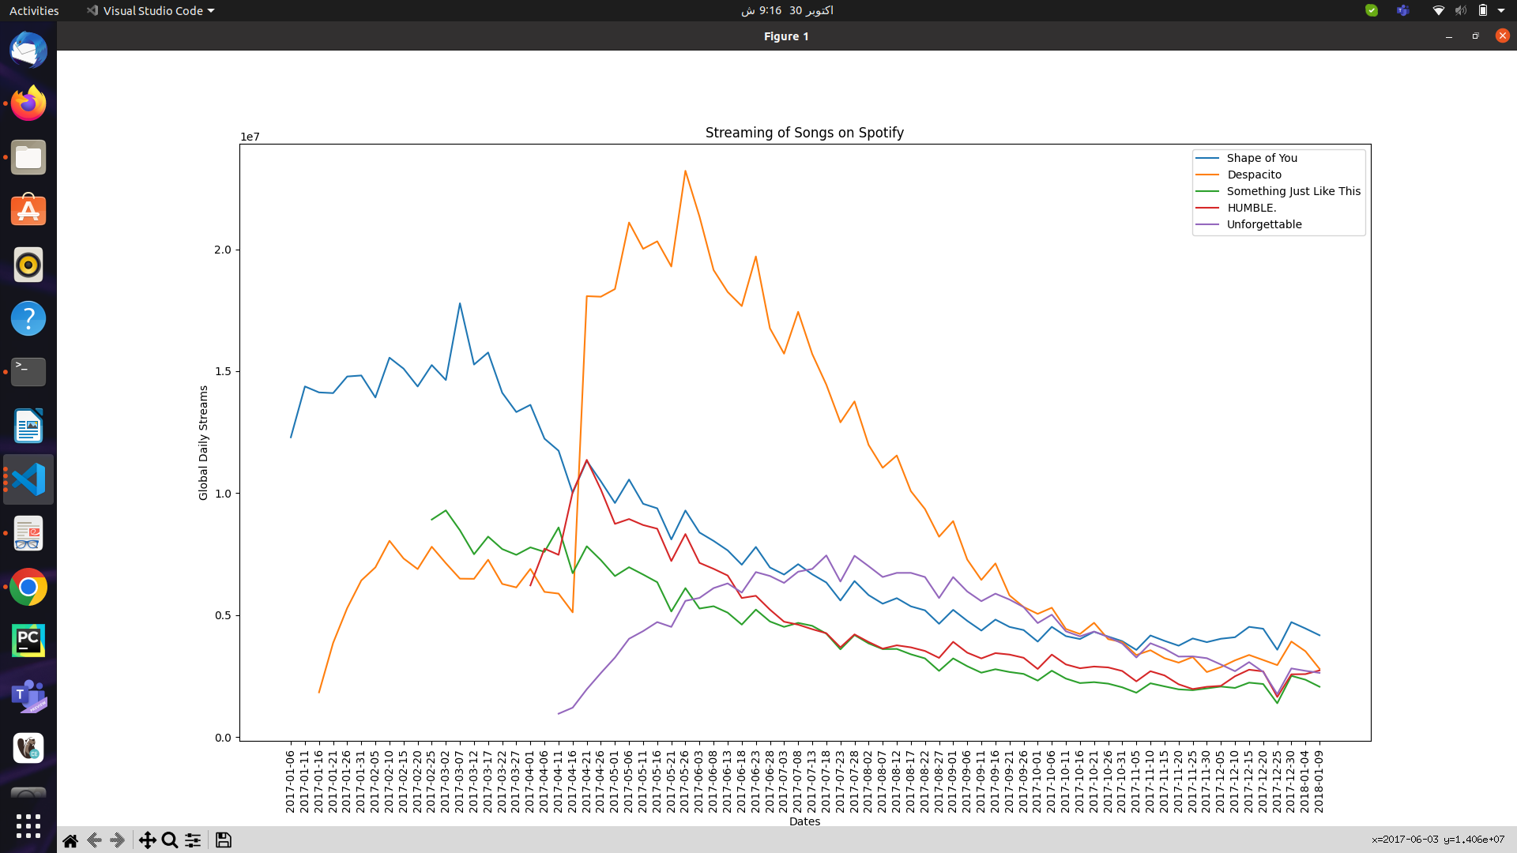

1. Produce graphs using two other visualisation methods. Explain why you picked this type of graph and describe what conclusions you can draw.

a)

**Data set:** <https://data.worldbank.org/indicator/NY.GDP.MKTP.KD.ZG>

**Description:**

The following plot depicts GDP of year 2021 of Arab World, Australia, Europe and Central Asia, United Kingdom, North America, Pakistan and United States.

Bar plot was picked because the data can be clearly visualized using bar plot where more the height of the bar more the growth and the growth of each country can also be easily compared with the others.

Plot depicts that among these 7 counties GDP of United Kingdom was highest in 2021, GDP of North America was average while GDP of Australia was lowest.

**Figure:**

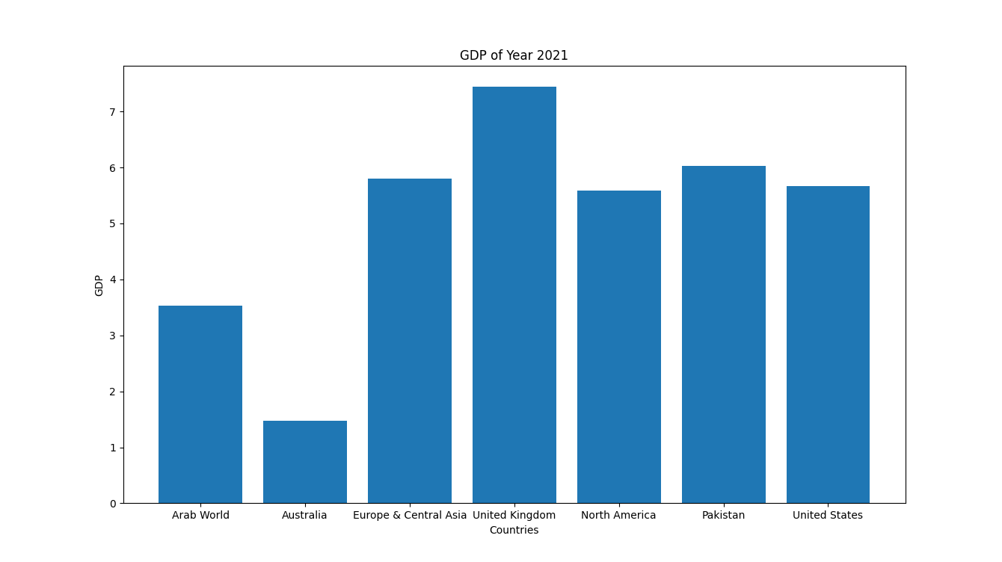

b)

**Data set:** <https://www.kaggle.com/code/alexisbcook/scatter-plots/data?select=insurance.csv>

**Description:**

The data set contains data about insurance. It has data regarding age, sex, BMI, number of children, smoker or not, region and charges paid by different customers. For scatter plot, BMI and charges were picked.

The scatterplot portrays that BMI and insurance charges are positively correlated. It can be observed that customers who have higher BMI tend to pay more in insurance costs. This pattern makes sense, as high BMI is typically associated with higher risk of chronic disease.

**Figure:**

